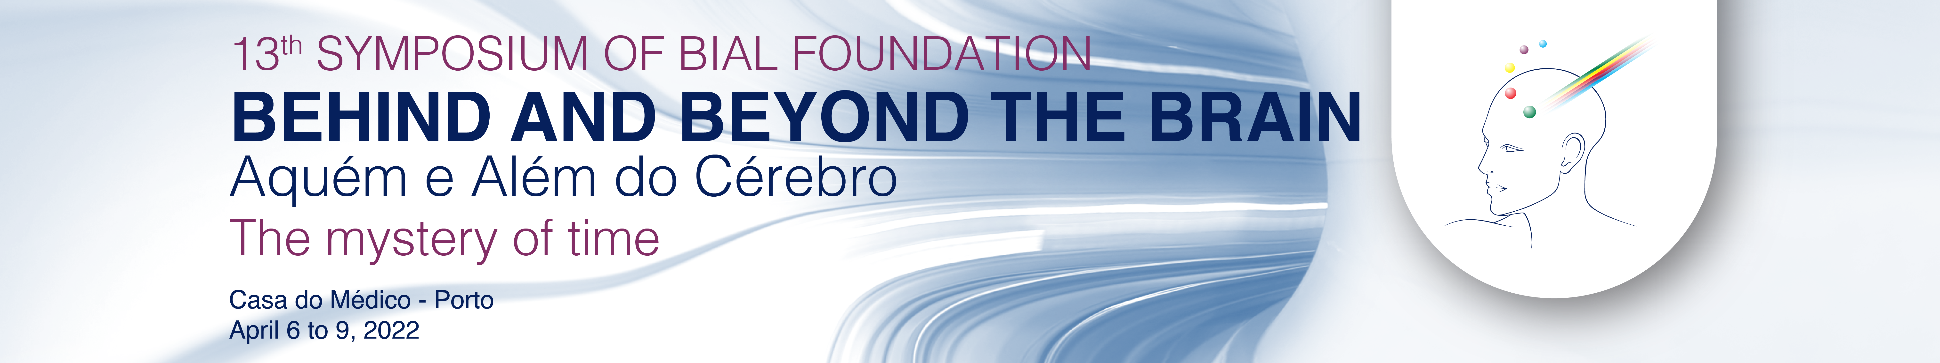

Virtual registration

Questionário de Avaliação Symposium Evaluation

Por favor, ajude-nos a organizar melhor o próximo Simpósio Aquém e Além do Cérebro preenchendo com um ☒ os quadrados que correspondem à sua opinião.
Please, help us to organize a better edition of Behind and Beyond the Brain Symposium filling in with an ☒ the following questions.

1 - Categoria dos participantes Category of respondents ☒
Médico Physician
Psicólogo Psychologist
Ciências Básicas Basic Sciences
Estudante Student
Outro. Qual? Other. Which?

☹ |  |  |  |  |  |  | ☺
1 | 2 |  | 3 |  | 4 |  | 5
Muito fraco Very poor |  | Fraco Poor |  | Razoável Fair |  | Bom Good | Muito Bom Very good

2 - Interesse do Simpósio Symposium interest | ☹ |  |  |  |  |  |  | ☺
 | 1 |  | 2 |  | 3 |  | 4 |  | 5
Conteúdo do programa Program content
Qualidade das apresentações Quality of presentations
Qualidade dos debates Quality of debates
Coerência do programa Coherence of the program
Duração do Simpósio Symposium length
Duração das palestras Lectures’ length

3 - Organização Organization | ☹ |  |  |  |  |  |  | ☺
 | 1 | 2 |  | 3 |  | 4 |  | 5
Qualidade da transmissão Live streaming quality
Funcionalidades disponíveis Available functionalities
Documentação disponibilizada Available documentation
App do Simpósio Symposium App
Tradução simultânea Simultaneous translation
Organização Organization

4 - Avaliação das sessões Sessions evaluation | ☹ |  |  |  |  |  |  | ☺
 | 1 | 2 |  | 3 |  | 4 |  | 5
Opening Conference
The arrow of time
The biology of time
The experience of time
A conversation about time
Apresentações orais de posters - Investigadores apoiados FB
Oral poster presentations - Bial Foundation grant holders

volte p.f. please turn over

5 - Avaliação das palestras Lectures evaluation
Preencha com um ☒ as palestras que considerou mais interessantes/estimulantes
Fill in with an ☒ the lectures that you found more interesting/stimulating
☒
Opening Conference
Anil Seth - The perception of time in humans, brains and machines
1st session - The arrow of time
Orfeu Bertolami - Time, the hidden dimension
Jimena Canales - The trouble with Einstein's time
Daniel Sheehan - Retrocausation and precognition: Taking time seriously
Bernard Carr - The many-faceted enigma of time: A physicist’s perspective
2nd session - The biology of time
Julia Mossbridge - Predictive anticipatory activity: How do biological systems pre-spond to future events?
Michael Brecht - Kinship: Life time memories
Joseph S. Takahashi - Circadian clocks and their impact on metabolism, aging and longevity
Wolf Singer - Time as construct and implicit coding space. A neurobiological perspective
3rd session - The experience of time
Dean Buonomano - The brain is a time machine: The neuroscience of time
Chris Roe - Remembering the future: Facilitating the recall of future events
Jennifer Coull - Visualising time in the brain: Perceiving the present and predicting the future
Marc Wittmann - How we experience the passage of time: The body, feelings, and the self
A conversation about time
Apresentações orais de posters - Investigadores apoiados pela Fundação Bial
Oral poster presentations - Bial Foundation grant holders

6 - Apreciação Geral General Assessment | ☹ |  |  |  |  |  | ☺
 | 1 | 2 | 3 |  | 4 |  | 5
O simpósio correspondeu às suas expectativas?
Did the symposium fulfil your expectations?
O simpósio é útil para a sua atividade profissional?
Was the symposium useful for your professional activity?

7 - Que tema gostaria de sugerir para a próxima edição do Simpósio?
Which theme would you like to suggest for the next edition of the Symposium?

____________________________________________________________________________
____________________________________________________________________________
____________________________________________________________________________

8 - Sugestões de Melhoria Suggestions

____________________________________________________________________________
____________________________________________________________________________
____________________________________________________________________________

Por favor envie o seu questionário para fundacao@bial.com. Obrigado pela colaboração.
Please send this form to fundacao@bial.com. Thank you for your collaboration.

