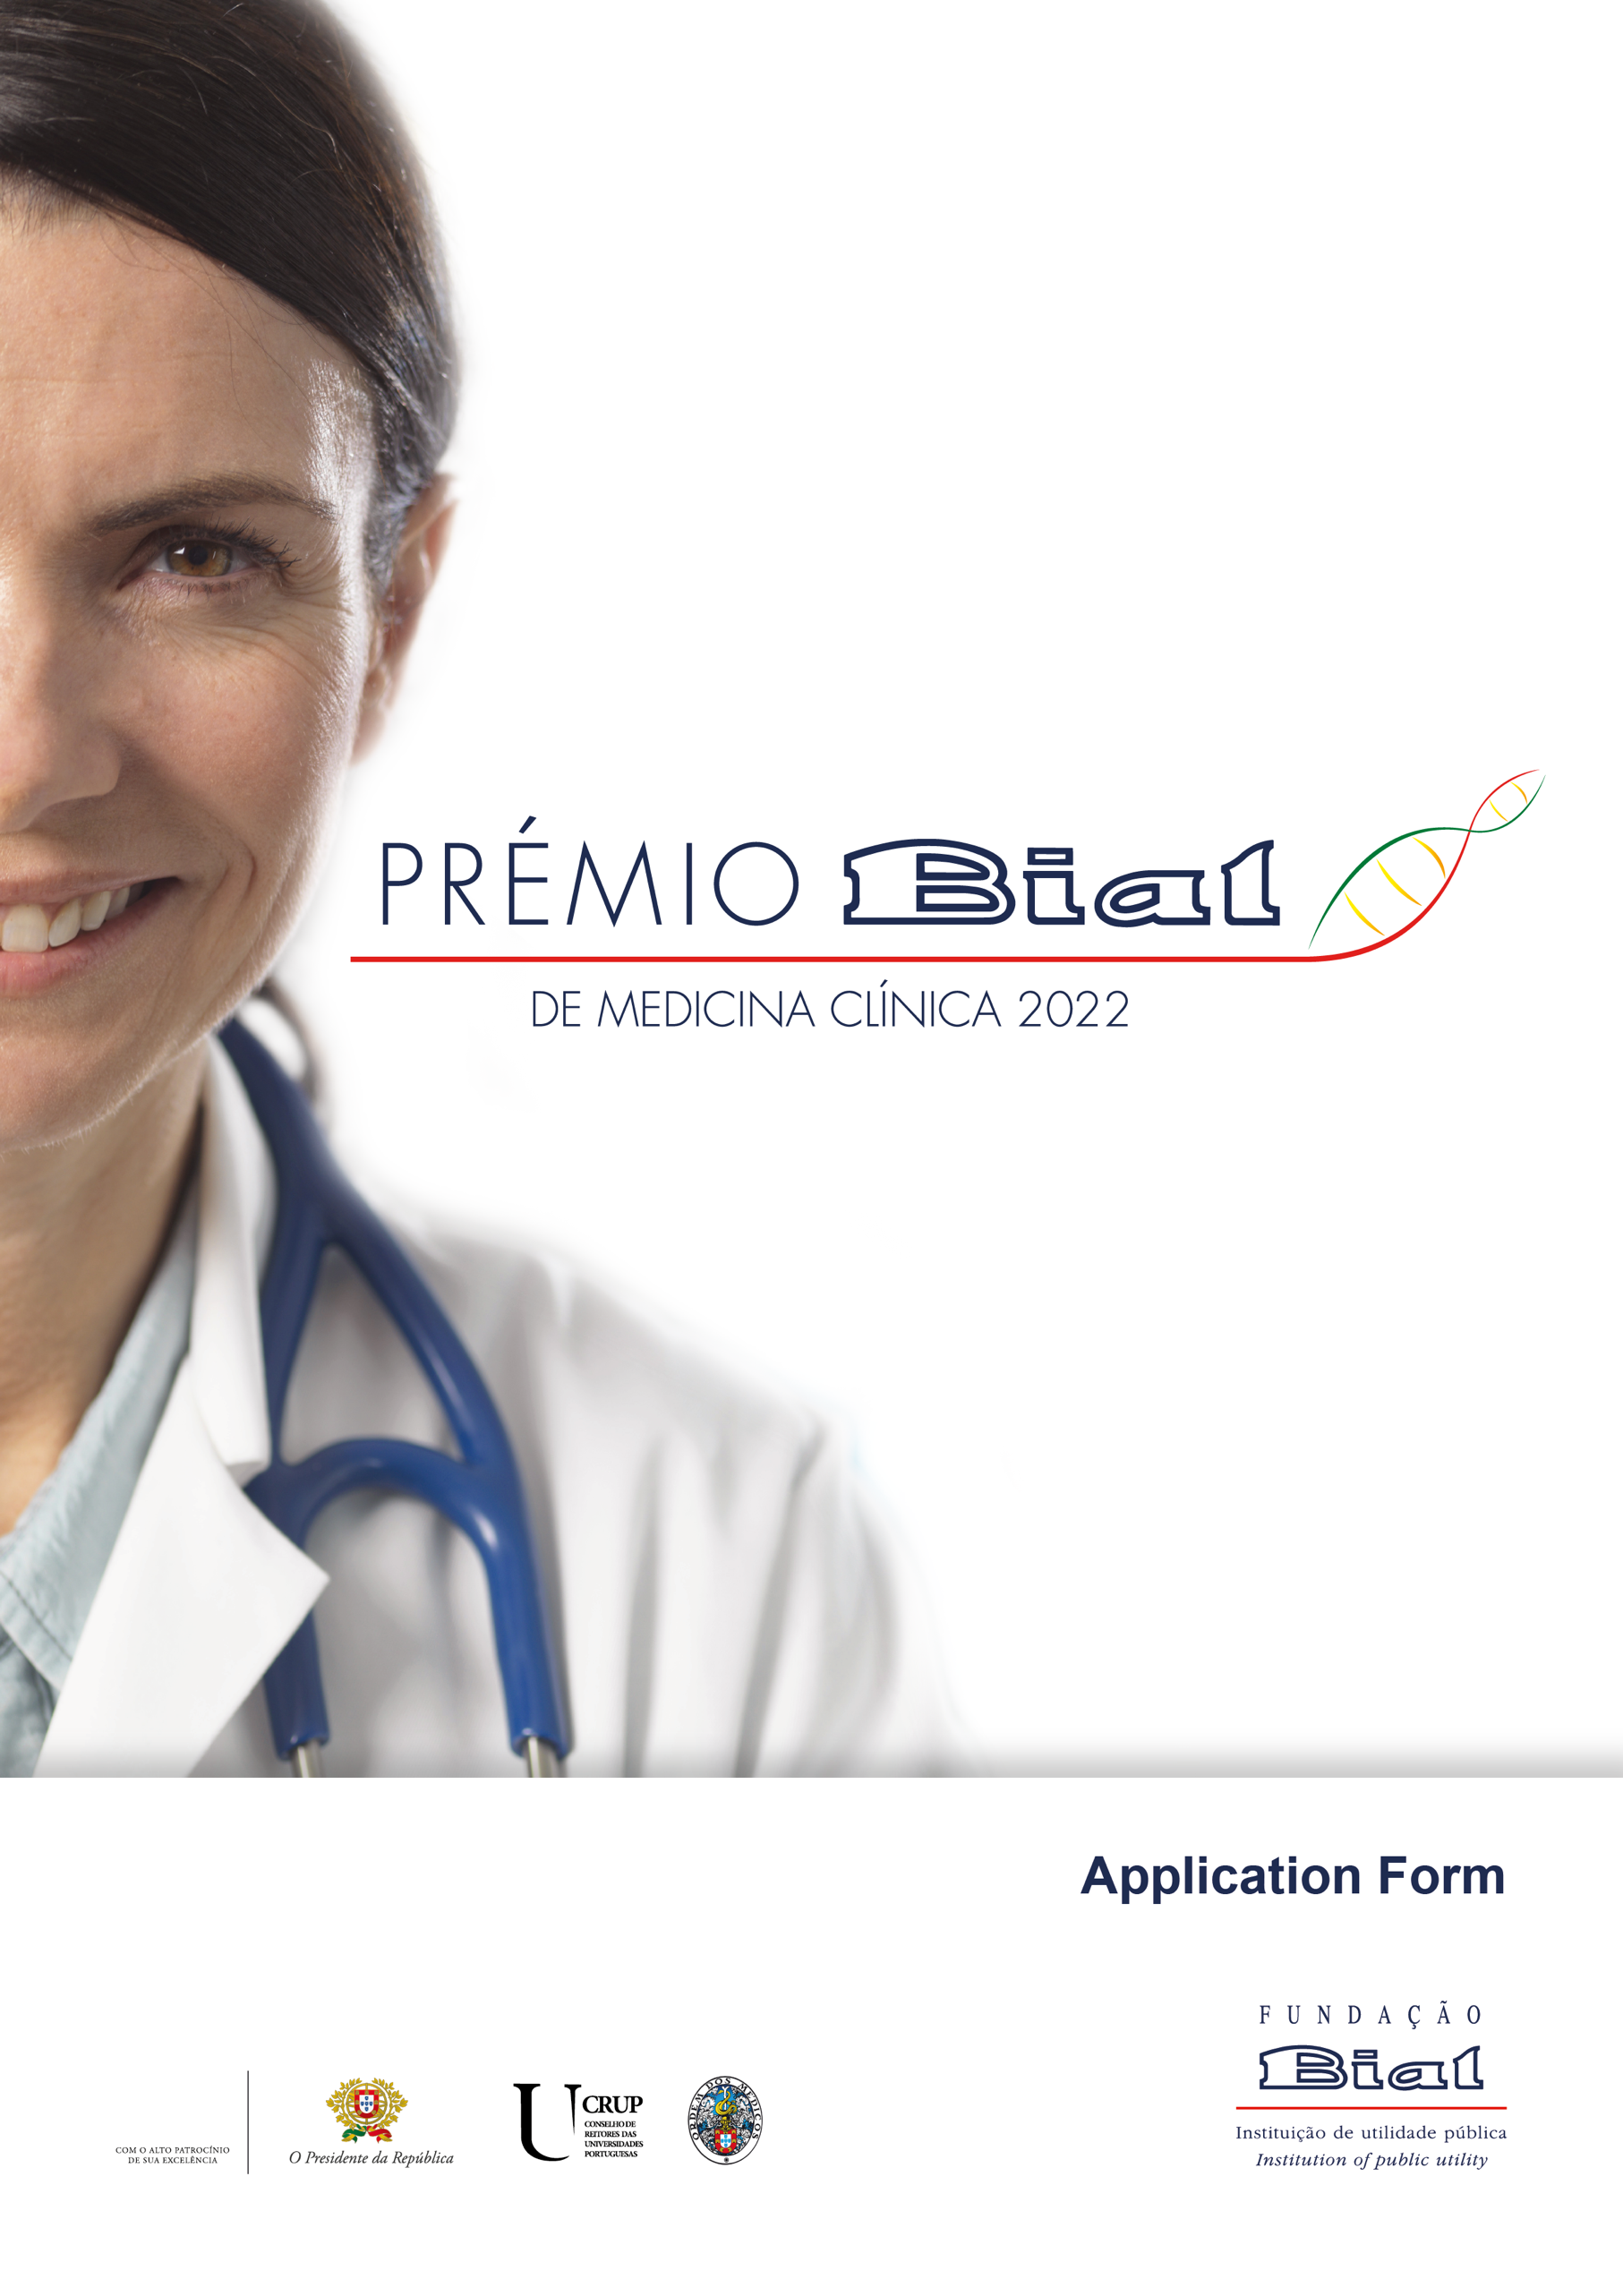

- IDENTIFICATION OF THE ENTERED WORK

Topic:

Title:

- AUTHOR(S) OF THE ENTERED WORK

  - LIST OF AUTHORS
Author | Name | % of contribution for the entered work* | CV  Attached
Author 1 – Presenter
Author 2
Author 3
Author 4
Author 5
Author 6
Author 7
Author 8
Author 9
Author 10
Author 11
Author 12
Author 13
Author 14
Author 15
Author 16
Author 17
Author 18
Author 19
Author 20
* Pursuant to no. 3 of point 11º of Prémio Bial de Medicina Clínica 2022 Regulation “In case the wining works have been created by several authors, the monetary value referred to in the preceding paragraphs will be divided and paid by the BIAL Foundation in equal parts to each of the coauthors identified in the winning work - unless in the relevant part of the Application Form (point 2.1: List of Authors), the authors fill in the column "% of contribution for the entered work", in which case the monetary value of the Award will be distributed in accordance with such percentages.”

  - IDENTIFICATION OF THE AUTHOR(S)
Author 1 – Presenter of the work
Full Name:
Professional Name:
Identity Card Citizen Card Passaport No.: |  |  | Expiry date: (choose a date)
National Insurance/Taxpayer No.:
Postal address:
Town/City: | Postcode: |  | Country:
Telephone: |  | Mobile phone:
E-mail:
Educational Qualification: Bachelor Master Doctorate
Other, Which?
Institutional Affiliation:
Professional address:
Town/City: | Postcode: |  | Country:
Telephone: |  | E-mail:

Author 2
Full Name:
Professional Name:
Identity Card Citizen Card Passaport No.: |  |  | Expiry date: (choose a date)
National Insurance/Taxpayer No.:
Postal address:
Town/City: | Postcode: |  | Country:
Telephone: |  | Mobile phone:
E-mail:
Educational Qualification: Bachelor Master Doctorate
Other, Which?
Institutional Affiliation:
Professional address:
Town/City: | Postcode: |  | Country:
Telephone: |  | E-mail:

Author 3
Full Name:
Professional Name:
Identity Card Citizen Card Passaport No.: |  |  | Expiry date: (choose a date)
National Insurance/Taxpayer No.:
Postal address:
Town/City: | Postcode: |  | Country:
Telephone: |  | Mobile phone:
E-mail:
Educational Qualification: Bachelor Master Doctorate
Other, Which?
Institutional Affiliation:
Professional address:
Town/City: | Postcode: |  | Country:
Telephone: |  | E-mail:

Author 4
Full Name:
Professional Name:
Identity Card Citizen Card Passaport No.: |  |  | Expiry date: (choose a date)
National Insurance/Taxpayer No.:
Postal address:
Town/City: | Postcode: |  | Country:
Telephone: |  | Mobile phone:
E-mail:
Educational Qualification: Bachelor Master Doctorate
Other, Which?
Institutional Affiliation:
Professional address:
Town/City: | Postcode: |  | Country:
Telephone: |  | E-mail:

Author 5
Full Name:
Professional Name:
Identity Card Citizen Card Passaport No.: |  |  | Expiry date: (choose a date)
National Insurance/Taxpayer No.:
Postal address:
Town/City: | Postcode: |  | Country:
Telephone: |  | Mobile phone:
E-mail:
Educational Qualification: Bachelor Master Doctorate
Other, Which?
Institutional Affiliation:
Professional address:
Town/City: | Postcode: |  | Country:
Telephone: |  | E-mail:

Author 6
Full Name:
Professional Name:
Identity Card Citizen Card Passaport No.: |  |  | Expiry date: (choose a date)
National Insurance/Taxpayer No.:
Postal address:
Town/City: | Postcode: |  | Country:
Telephone: |  | Mobile phone:
E-mail:
Educational Qualification: Bachelor Master Doctorate
Other, Which?
Institutional Affiliation:
Professional address:
Town/City: | Postcode: |  | Country:
Telephone: |  | E-mail:

Author 7
Full Name:
Professional Name:
Identity Card Citizen Card Passaport No.: |  |  | Expiry date: (choose a date)
National Insurance/Taxpayer No.:
Postal address:
Town/City: | Postcode: |  | Country:
Telephone: |  | Mobile phone:
E-mail:
Educational Qualification: Bachelor Master Doctorate
Other, Which?
Institutional Affiliation:
Professional address:
Town/City: | Postcode: |  | Country:
Telephone: |  | E-mail:

Author 8
Full Name:
Professional Name:
Identity Card Citizen Card Passaport No.: |  |  | Expiry date: (choose a date)
National Insurance/Taxpayer No.:
Postal address:
Town/City: | Postcode: |  | Country:
Telephone: |  | Mobile phone:
E-mail:
Educational Qualification: Bachelor Master Doctorate
Other, Which?
Institutional Affiliation:
Professional address:
Town/City: | Postcode: |  | Country:
Telephone: |  | E-mail:

Author 9
Full Name:
Professional Name:
Identity Card Citizen Card Passaport No.: |  |  | Expiry date: (choose a date)
National Insurance/Taxpayer No.:
Postal address:
Town/City: | Postcode: |  | Country:
Telephone: |  | Mobile phone:
E-mail:
Educational Qualification: Bachelor Master Doctorate
Other, Which?
Institutional Affiliation:
Professional address:
Town/City: | Postcode: |  | Country:
Telephone: |  | E-mail:

Author 10
Full Name:
Professional Name:
Identity Card Citizen Card Passaport No.: |  |  | Expiry date: (choose a date)
National Insurance/Taxpayer No.:
Postal address:
Town/City: | Postcode: |  | Country:
Telephone: |  | Mobile phone:
E-mail:
Educational Qualification: Bachelor Master Doctorate
Other, Which?
Institutional Affiliation:
Professional address:
Town/City: | Postcode: |  | Country:
Telephone: |  | E-mail:

Author 11
Full Name:
Professional Name:
Identity Card Citizen Card Passaport No.: |  |  | Expiry date: (choose a date)
National Insurance/Taxpayer No.:
Postal address:
Town/City: | Postcode: |  | Country:
Telephone: |  | Mobile phone:
E-mail:
Educational Qualification: Bachelor Master Doctorate
Other, Which?
Institutional Affiliation:
Professional address:
Town/City: | Postcode: |  | Country:
Telephone: |  | E-mail:

Author 12
Full Name:
Professional Name:
Identity Card Citizen Card Passaport No.: |  |  | Expiry date: (choose a date)
National Insurance/Taxpayer No.:
Postal address:
Town/City: | Postcode: |  | Country:
Telephone: |  | Mobile phone:
E-mail:
Educational Qualification: Bachelor Master Doctorate
Other, Which?
Institutional Affiliation:
Professional address:
Town/City: | Postcode: |  | Country:
Telephone: |  | E-mail:

Author 13
Full Name:
Professional Name:
Identity Card Citizen Card Passaport No.: |  |  | Expiry date: (choose a date)
National Insurance/Taxpayer No.:
Postal address:
Town/City: | Postcode: |  | Country:
Telephone: |  | Mobile phone:
E-mail:
Educational Qualification: Bachelor Master Doctorate
Other, Which?
Institutional Affiliation:
Professional address:
Town/City: | Postcode: |  | Country:
Telephone: |  | E-mail:

Author 14
Full Name:
Professional Name:
Identity Card Citizen Card Passaport No.: |  |  | Expiry date: (choose a date)
National Insurance/Taxpayer No.:
Postal address:
Town/City: | Postcode: |  | Country:
Telephone: |  | Mobile phone:
E-mail:
Educational Qualification: Bachelor Master Doctorate
Other, Which?
Institutional Affiliation:
Professional address:
Town/City: | Postcode: |  | Country:
Telephone: |  | E-mail:

Author 15
Full Name:
Professional Name:
Identity Card Citizen Card Passaport No.: |  |  | Expiry date: (choose a date)
National Insurance/Taxpayer No.:
Postal address:
Town/City: | Postcode: |  | Country:
Telephone: |  | Mobile phone:
E-mail:
Educational Qualification: Bachelor Master Doctorate
Other, Which?
Institutional Affiliation:
Professional address:
Town/City: | Postcode: |  | Country:
Telephone: |  | E-mail:

Author 16
Full Name:
Professional Name:
Identity Card Citizen Card Passaport No.: |  |  | Expiry date: (choose a date)
National Insurance/Taxpayer No.:
Postal address:
Town/City: | Postcode: |  | Country:
Telephone: |  | Mobile phone:
E-mail:
Educational Qualification: Bachelor Master Doctorate
Other, Which?
Institutional Affiliation:
Professional address:
Town/City: | Postcode: |  | Country:
Telephone: |  | E-mail:

Author 17
Full Name:
Professional Name:
Identity Card Citizen Card Passaport No.: |  |  | Expiry date: (choose a date)
National Insurance/Taxpayer No.:
Postal address:
Town/City: | Postcode: |  | Country:
Telephone: |  | Mobile phone:
E-mail:
Educational Qualification: Bachelor Master Doctorate
Other, Which?
Institutional Affiliation:
Professional address:
Town/City: | Postcode: |  | Country:
Telephone: |  | E-mail:

Author 18
Full Name:
Professional Name:
Identity Card Citizen Card Passaport No.: |  |  | Expiry date: (choose a date)
National Insurance/Taxpayer No.:
Postal address:
Town/City: | Postcode: |  | Country:
Telephone: |  | Mobile phone:
E-mail:
Educational Qualification: Bachelor Master Doctorate
Other, Which?
Institutional Affiliation:
Professional address:
Town/City: | Postcode: |  | Country:
Telephone: |  | E-mail:

Author 19
Full Name:
Professional Name:
Identity Card Citizen Card Passaport No.: |  |  | Expiry date: (choose a date)
National Insurance/Taxpayer No.:
Postal address:
Town/City: | Postcode: |  | Country:
Telephone: |  | Mobile phone:
E-mail:
Educational Qualification: Bachelor Master Doctorate
Other, Which?
Institutional Affiliation:
Professional address:
Town/City: | Postcode: |  | Country:
Telephone: |  | E-mail:

Author 20
Full Name:
Professional Name:
Identity Card Citizen Card Passaport No.: |  |  | Expiry date: (choose a date)
National Insurance/Taxpayer No.:
Postal address:
Town/City: | Postcode: |  | Country:
Telephone: |  | Mobile phone:
E-mail:
Educational Qualification: Bachelor Master Doctorate
Other, Which?
Institutional Affiliation:
Professional address:
Town/City: | Postcode: |  | Country:
Telephone: |  | E-mail:

- SUMMARY OF THE ENTERED WORK

(Note: 7,000 characters maximum, including spaces)

- ATTACHMENTS

To attach:
- Author(s) Curriculum vitae.
- The entered work, in PDF file, without restrictions, containing no more than 200 pages, Arial font, size 12pt, 1.5 line spacing.
- Editable version of the completed Application Form (if the version signed by the author or authors is not editable).

- DECLARATION (required under point 5 of the PRÉMIO BIAL DE MEDICINA CLÍNICA 2022 Regulation)

, author (or co-authors identified in this Application Form signed by him/her/them) of the intellectual work on the medical topic entitled entered for the PRÉMIO BIAL DE MEDICINA CLÍNICA 2022 declare that he/she has / they have been informed about the complete content of the Regulation of the PRÉMIO BIAL DE MEDICINA CLÍNICA 2022, in particular of the provisions of its point 11, to which he/she fully and completely agrees / they fully and completely agree.
Therefore he/she agrees / they agree to cooperate with the Award organization, in everything stipulated or implicit in this Regulation.
He/she acknowledges and expressly accepts / They acknowledge and expressly accept that the operation of collecting and processing of personal data is necessary within the scope and sole purpose of this competition.
He/she expressly authorizes / They expressly authorize the use of the PDF file of his/her/their work under the terms established in the aforementioned Regulation specifically in terms of electronic transmission thereof as mentioned in point 6 of the said Regulation.
He/she declares / They declare that the entry is an original work and that he/she/ they will refrain from any actions or initiatives that may reduce the interest or novelty of the work, except with a written favourable opinion, given beforehand by the organizers of this Award up to the announcement of the results, pursuant to point 15 of this Regulation.

- PROCESSING OF PERSONAL DATA

- The BIAL Foundation is the controller for the processing of the personal data collected from the candidates for the PRÉMIO BIAL DE MEDICINA CLÍNICA 2022. The BIAL Foundation adopts personal data protection and security practices in compliance with the General Data Protection Regulation (GDPR), as well as national legislation in force.
- The BIAL Foundation collects the personal data provided in the application form, as well as those sent by candidates by email in connection with the competition exclusively within the scope of and for the PRÉMIO BIAL DE MEDICINA CLÍNICA 2022 competition for the following purposes: management of the competition, which includes the receipt, analysis and evaluation of the applications, the communication of the data to the members of the Jury identified in the Regulation, the allocation and communication of the prizes, the promotion, dissemination and announcement of the winners and for the purposes of promotion and dissemination of future competitions with the same purpose.
- The basis for the collection and processing of personal data corresponds to pre-contractual proceedings and execution of contract (cf. Article 6, Paragraph 1, a) and b) of the GDPR). Should the collection of personal data other than those referred to above be required, which, due to their nature, lacks the express and prior consent of the data subject, the BIAL Foundation will request prior consent from the data subject, who will always be entitled to withdraw such consent at any time (however, this right does not compromise the lawfulness of processing on another legal basis).
- Personal data will be processed and stored in digital format. The BIAL Foundation has adopted appropriate technical and organisational measures for the security and protection of personal data.
The BIAL Foundation ensures that personal data will be processed for no longer than is necessary for the purposes for which it was collected.
Given the relevance of PRÉMIO BIAL DE MEDICINA CLÍNICA 2022, and for archiving purposes in the public interest, the BIAL Foundation reserves the right to store the data contained in the applications received for historical and/or statistical purposes, unless this has been opposed by the data subject.
- The BIAL Foundation guarantees to the data subject the right of access to his/her personal data at any time, as well as the rectification, erasure, portability, restriction and/or objection to the processing thereof. The data subject has the right to request BIAL Foundation to erase his/her data without undue delay, and the BIAL Foundation is under an obligation to erase the personal data without undue delay when, inter alia, one of the following reasons applies:
- the personal data is no longer necessary for the purpose for which it was collected;
- the data subject has withdrawn his/her consent to the processing of personal data (in cases where the processing is based on consent) and there is no other legal basis for the processing; or
- the data subject objects to the processing and there are no prevailing legitimate interests that justify the processing.
In order to exercise any of these rights, the data subject must contact the BIAL Foundation in writing at the registered office address or via the following email address fundacao@bial.com.
Requests will be handled with particular care in order to ensure the effectiveness of the rights of the data subject.
When the BIAL Foundation has reasonable doubts as to the identity of the person submitting the request, it may request that additional information necessary to confirm his/her identity be provided.
In addition, the data subject has the right to submit a complaint to the data protection authority, in particular if he/she does not obtain a response to the exercise of his or her rights or identifies any irregularity in the processing of such data.
- Within the context of the promotion of the PRÉMIO BIAL DE MEDICINA CLÍNICA 2020, the BIAL Foundation may turn to third parties for the provision of certain services (located inside or outside the European Union), which may, in some situations, imply access to personal data by such entities. In this case, the BIAL Foundation undertakes to adopt the necessary and appropriate measures to ensure that the entities having access to such personal data offer high guarantees at this level, which will be duly safeguarded in a contract concluded between the BIAL Foundation and the third-party entity(ies).
Indeed, any entity subcontracted by the BIAL Foundation will process personal data in the name and on behalf of the BIAL Foundation, under the commitment of taking the necessary technical and organisational measures to protect personal data against accidental or unlawful destruction, accidental loss, unauthorised alteration, dissemination or access and against any other form of unlawful processing.
To learn more about the processing of personal data by the BIAL Foundation, you can consult the Privacy Policy available on the website.

If you would like to receive further information about the activities of the BIAL Foundation, please tick the following field:
I want to receive more information about events and other informational and/or promotional campaigns related to the BIAL Foundation.

I have learned the PRÉMIO BIAL DE MEDICINA CLÍNICA 2022 through:

Website Social Networks News in the media Media advertising Mailing

Other, Which?

Author Signature(s)1: Date
yyyy/mm/dd
Author 1 – Presenter |  | (choose a date)
Author 2 |  | (choose a date)
Author 3 |  | (choose a date)
Author 4 |  | (choose a date)
Author 5 |  | (choose a date)
Author 6 |  | (choose a date)
Author 7 |  | (choose a date)
Author 8 |  | (choose a date)
Author 9 |  | (choose a date)
Author 10 |  | (choose a date)
Author 11 |  | (choose a date)
Author 12 |  | (choose a date)
Author 13 |  | (choose a date)
Author 14 |  | (choose a date)
Author 15 |  | (choose a date)
Author 16 |  | (choose a date)
Author 17 |  | (choose a date)
Author 18 |  | (choose a date)
Author 19 |  | (choose a date)
Author 20 |  | (choose a date)

1 In accordance with the Regulation of the Prémio Bial de Medicina Clínica 2022, this Application Form includes the declaration set forth in point 5 of such Regulation and it must be signed by the author or all authors of the entered work.

